**EXPERIMENT 2**

**AIM: Working with Docker (Basic Commands)**

**Steps to Complete:**

1. Search a Redis image on DockerHub

Solution:

**Command: docker search redis**

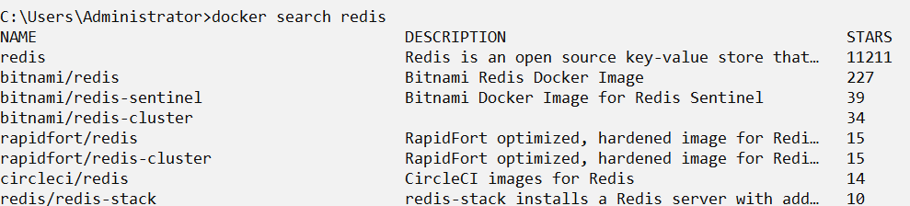

1. Run Docker Container of Redis Image in background

**Command: docker run -d redis**

**Command: docker ps**

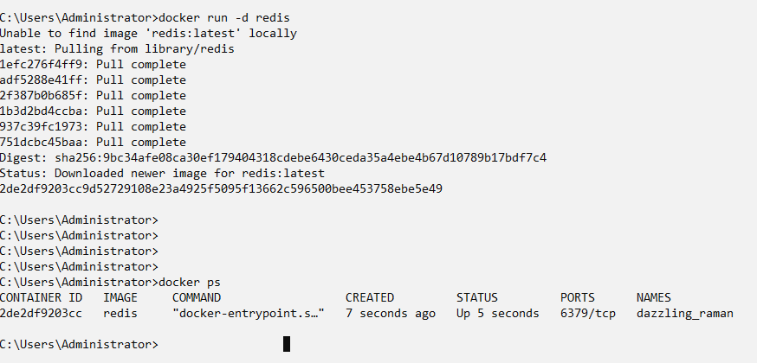

1. Run Docker PS and Docker PS –a



1. Run Docker Container and take its console

Command: docker run -it redis /bin/bash

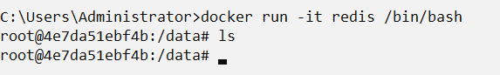

1. Create a Docker Volume and connect it

Command: docker run -it -v myvol:/data redis /bin/bash

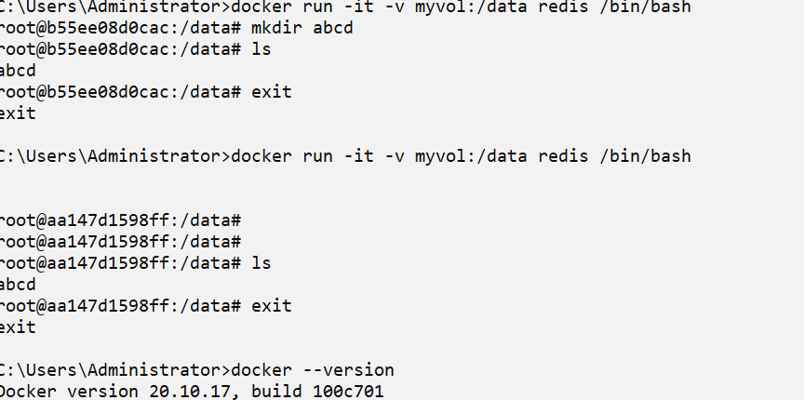

\\wsl$\docker-desktop-data\data\docker\volumes